Project Design Phase
Security and Access Control Design (Supplementary)
Date | 28 October 2026
Team ID | To Be Confirmed
Project Name | HotelPro – Hotel Management System
Maximum Marks | Supplementary
Document Status | Draft v1.0 – prepared from the stated HotelPro requirements. No HotelPro source code has been provided or verified, so all features are marked Planned.

1. Introduction
This document specifies the planned security controls for HotelPro: authentication, authorisation, JWT validation, password hashing, protected routes, role-based access control (RBAC), input validation, email verification, payment security, activity logging and session management. All controls are Planned; none is claimed to be implemented or verified.

2. Security Control Summary
Table 1: Security controls
Control | Planned Approach | Requirement | Status
Authentication | Email + password login; bcryptjs hash; JWT issued on success | FR-G2 | Planned
Password hashing | bcryptjs with salt rounds ≥ 10 (value TBC); never store or log plaintext | FR-G1 | Planned
JWT validation | verifyToken middleware: signature, expiry, user still active | FR-X1 | Planned
Authorisation (RBAC) | authorize(...roles) middleware; staff sub-role for manager functions | FR-X1 | Planned
Protected routes (UI) | React Router guard component redirects unauthenticated/unauthorised users | FR-X1 | Planned
Input validation | Server-side schema validation and sanitisation (library TBC); client-side checks for UX | FR-X2 | Planned
Email verification | Single-use, expiring token sent by Nodemailer | FR-X3 | Planned
Payment security | Gateway-hosted card entry; server-side signature/webhook verification; idempotency; amount check | FR-G6 | Planned
Activity logging | adminlogs for logins, failures, admin writes, refunds | FR-X4 | Planned
Session management | Short-lived token, logout, optional refresh token, re-login on expiry | FR-G2 | Planned
Transport and headers | HTTPS, helmet headers, restricted CORS, rate limiting | NFR-2 | Planned

3. Authentication and Session Flow
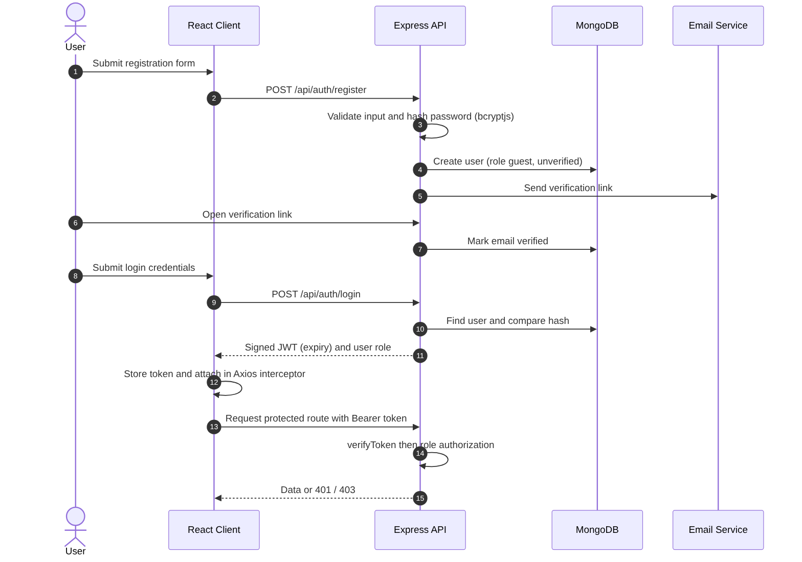
Figure 1: Registration, email verification, login and protected request flow

3.1 JWT Design
Table 2: JWT design
Aspect | Design
Payload | userId, role (and staffRole where applicable), issued-at, expiry – no sensitive data
Signing | HMAC with JWT_SECRET from environment (never in source control)
Expiry | Short access-token lifetime (value TBC); refresh-token strategy is optional and TBC
Transport | Authorization: Bearer <token> header
Client storage | Decision TBC: httpOnly secure cookie (better XSS protection, needs CSRF controls) vs in-memory/localStorage (simpler, exposed to XSS)
Revocation | Logout clears client token; server checks isActive on each request so deactivated users lose access

4. Role-Based Access Control Matrix
Roles: Guest, Staff (with sub-roles receptionist, housekeeping, service, support), Manager (staff sub-role representing Hotel Management) and Admin. ✔ = allowed, own = own records only, – = denied.
Table 3: RBAC matrix (proposed)
Resource / Action | Public | Guest | Staff | Manager | Admin
Browse and search rooms | ✔ | ✔ | ✔ | ✔ | ✔
Create booking | – | ✔ own | ✔ (walk-in) | ✔ | ✔
View bookings | – | own | hotel | hotel | all
Cancel booking | – | own | ✔ | ✔ | ✔
Approve modification / refund | – | – | – | ✔ | ✔
Make payment | – | ✔ own | – | – | –
Check-in / check-out | – | – | ✔ | ✔ | ✔
Update room status | – | – | ✔ | ✔ | ✔
Housekeeping tasks | – | – | assigned | ✔ assign | ✔
Service requests | – | create / own | handle | ✔ | ✔
Edit rooms, categories, prices | – | – | – | ✔ | ✔
Seasonal pricing rules | – | – | – | ✔ | ✔
Occupancy dashboard | – | – | – | ✔ | ✔
Write review | – | ✔ completed stay | – | – | –
Hide review | – | – | – | – | ✔
Manage users, hotels, staff | – | – | – | staff (hotel) | ✔
Payment tracking | – | own | – | hotel | all
Reports and analytics | – | – | – | hotel | all
Security logs and configuration | – | – | – | – | ✔

5. Detailed Controls

5.1 Password Security
- Hash with bcryptjs; compare with the library’s constant-time compare.
- Enforce minimum length and complexity (policy TBC); block common passwords (optional).
- Password reset tokens: random, hashed in the database, single-use, short expiry.
- Planned lockout/throttling after repeated failed logins; log each failure.

5.2 Input Validation and Injection Defence
- Validate type, length, format and range for all body, query and path parameters.
- Reject unexpected fields (mass-assignment protection): users cannot set role, price totals or status.
- Strip MongoDB operators ($, .) from user input to prevent NoSQL injection.
- Escape/sanitise free-text fields (reviews, notes) to prevent stored XSS.
- Restrict uploads by MIME type, extension and size; rename files; store outside the code directory.

5.3 Payment Security
- Card details are entered only in gateway-hosted components; HotelPro stores gateway ids and status only.
- Server calculates the payable amount; gateway amount must match booking total.
- Verify payment signatures / webhook signatures using the secret from environment variables.
- Process each webhook event id once (idempotency); handle retries and out-of-order events.
- Refunds are initiated only by Manager/Admin after approval and are logged.

5.4 Activity Logging and Monitoring
- Log: login success/failure, role or status changes, price/rule changes, refunds, report exports and configuration changes.
- Never log passwords, tokens or full payment details.
- Admin log viewer with filters by actor, action and date (FR-A5).

5.5 Transport, Headers and Configuration
- HTTPS only in production; HSTS via helmet.
- CORS allow-list limited to CLIENT_URL.
- Rate limiting on login, registration and password-reset endpoints.
- Secrets only in environment variables; .env excluded from Git; keys rotated if exposed.

6. Threat Analysis (Initial)
Table 4: Threat analysis
Threat | Example | Mitigation | Test Reference
Spoofing | Stolen or forged token | Signed, expiring JWT; HTTPS; active-user check | TC-SEC series
Tampering | Client changes price or role in request | Server-side price calculation; whitelist fields | TC-SEC series
Repudiation | Admin denies a change | Audit log with actor and time | TC-ADM series
Information disclosure | Guest views another guest’s booking | Ownership checks on every resource | TC-SEC series
Denial of service | Login or search flooding | Rate limiting, pagination, indexes | Performance tests (TBC)
Elevation of privilege | Guest calls admin API | authorize middleware on every route | TC-SEC series

References
- OWASP Authentication Cheat Sheet – https://cheatsheetseries.owasp.org/cheatsheets/Authentication_Cheat_Sheet.html
- OWASP Password Storage Cheat Sheet – https://cheatsheetseries.owasp.org/cheatsheets/Password_Storage_Cheat_Sheet.html
- OWASP JSON Web Token Cheat Sheet – https://cheatsheetseries.owasp.org/cheatsheets/JSON_Web_Token_for_Java_Cheat_Sheet.html
- OWASP Top 10 – https://owasp.org/www-project-top-ten/
- helmet – https://helmetjs.github.io/
- RFC 7519 – JSON Web Token – https://datatracker.ietf.org/doc/html/rfc7519

